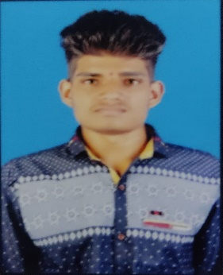 **RESUME**

**VITTHAL GORE**

**+91 70836 29759**

**Email Id: gorevitthal847@gmail.com**

**OBJECTIVE**

To work with an organization where can learn new skills and increase my abilities for the organizational goals as well as myself.

**EDUCATIONAL QUALIFICATION**

* Pursuing B.com 1st year from SPPU.
* Passed out 12th from Maharashtra State Board in 2022
* Passed out 10th from Maharashtra State Board in 2020

Marks 74.20%

**OTHER ACADAMIC DETAILS**

Completed NCC Course

Praticipited in Camps

**TECHNICAL SKILLS**

Basic Knowledge of Computer

**WORK EXPERIENCE**

Ecorea & Kuroda Electric India Private Limited

**STRENGTH & HOBBIES**

* Hard & Smart Working
* Self Motivated
* Good Communication Skill
* Cricket, Cooking, driving , Swimming, Workout, Watching Movie.

**PERSONAL DETAILS**

Father’s Name : Mr. Maruti Dada Gore

Date of Birth : 22-05-2004

Address : Belwandi bk., Tal. Shrigonda, Dist. Ahmednagar 413702.